**CHAPTER 1**

1. **INTRODUCTION**

# Our project is an example of server to server communication which is basically based on public chatting (message is broadcasted to all connected users in a room).The app allows multiple users to chat together. The messages will be updated without refreshing the page. For simplicity we will be avoiding the authentication part.The user should enter user name to chat.

* 1. **PURPOSE OF THE PROJECT**

# Our university website doesn’t have a real time chat feature.

# So it is very difficult for the user to get instant answers of their query.

# We also face the same problem in the period of covid-19.

# So we are decided to make our minor project to fix this issue.

# As we are providing the room feature to the project so it is very easy to answer the query of outside user as well as university user.

* 1. **TECHNICAL DETAILS**

## SOFTWARE REQUIREMENTS:

* HTML(Hyper Text Markup Language) , CSS (Cascading Style Sheet) (Front End)
* JAVASCRIPT , NODE JS , EXPRESS , WEB SOCKETS.IO (Back End)
* Microsoft Windows , Linux , Mac (All OF THEM)
* Internet Explorer (5.0 and above) or Mozilla Firefox (6.0 and above)
* VSCODE text editor, A Bash terminal / command prompt.

## HARDWARE REQUIREMENTS:

* Intel core 2 (minimum spec)
* Ram :- 2 GB
* Computer Memory :- 128 GB
* Intel HD graphics (minimum version 15.40.46.5144)

**CHAPTER 2**

**2. IMPLEMENTATION / TECHNOLOGY ENVIRONMENT**

# Explanation:

# 2.1 Tools and Technology used

# FRONTEND

# We are using HTML, CSS, JAVASCRIPT for the frontend part

# BACKEND

# We are using NODE.JS for the backend logics.

# We are using WEB SOCKETS for the real time communication.

# And we are using EXPRESS.JS for the server of the site.

# HTML

# HTML (Hypertext Markup Language) is the most basic building block of the Web. It defines the meaning and structure of web content.

# 2.3 CSS

# Cascading Style Sheets (CSS) is style sheet language used to describe the presentation of a document written in HTML or XML .CSS describes how elements should be rendered on screen, on paper, in speech, or on other media.

# 2.4 JavaScript

# JavaScript is a programming language that allows you to implement complex things on web pages. Every time a web page does more than just sit there and display static information for you to look at—displaying timely content updates, interactive maps , scrolling video jukeboxes, or more.

### ****2.5 Node.js****

[Node.js](https://en.wikipedia.org/wiki/Node.js) is an open-source, cross-platform JavaScript run-time environment that executes JavaScript code outside the browser. The most important advantage of using Node is that we can use JavaScript as both a front-end and back-end language.

As we know, JavaScript was used primarily for client-side scripting, in which scripts were embedded in a webpage’s HTML and run client-side by a JavaScript engine in the user’s web browser.

Node.js lets developers use JavaScript to write Command Line tools and for server-side scripting — running scripts server-side to produce dynamic web page content before the page is sent to the user’s web browser.

**2.6 Introduction to Web Socket**

Web Sockets are very beautiful tools that allow us to establish a real-time communication in modern web applications. In fact this mechanism is so powerful and it’s used to build different kind of apps like real-time chat or notification system etc..

1. Protocol providing **full-duplex communication** channel over single **TCP connection.**

1. Web was built around the idea – **'Client requests, Server fulfills'.**
2. AJAX got people started to look for ***bidirectional*** connections.
3. Other strategies like **long-polling** had the problem of **carry overhead**, leading to increase in latency.

**2.7 How does Web Sockets Work?**

**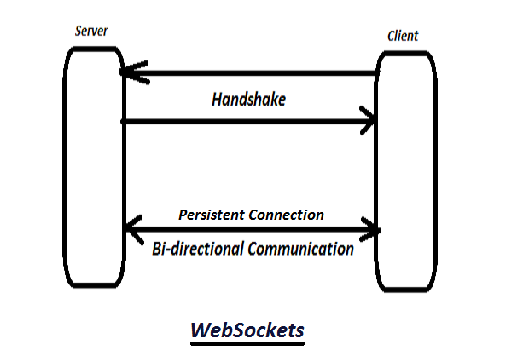**

**FIG 1**

**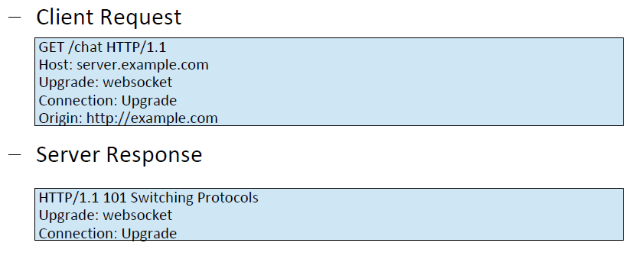**

**FIG 2**

* + 1. Establish connection through 'Web Socket Handshake'
    2. After handshake, initial HTTP connection is replaced by Web Socket connection (uses same underlying TCP/IP).
    3. Transfer data without incurring any overhead associated with requests.
  1. **Introduction to Socket.IO**

Socket.IO is a library that enables real-time, bidirectional and event-based communication between the browser and the server. It consists of:

* a Node.js server: [Source](https://github.com/socketio/socket.io) | [API](https://socket.io/docs/v3/server-api/)
* a JavaScript client library for the browser (which can be also run from Node.js): [Source](https://github.com/socketio/socket.io-client) | [API](https://socket.io/docs/v3/client-api/)

1. **JavaScript library** for **realtime** web applications.
2. Has two parts:

– **Client-side** – Runs on Browser

– **Server-side** – Runs on Server – Node.js

1. Primarily uses **WebSocket**, but can **fallback** to other methods like **AJAX long** polling, **JSONP** polling.
2. In addition to one-to-one communication as in WebSocket, it enables

**broadcasting** to multiple nodes.

* 1. **With Node HTTP Server**

**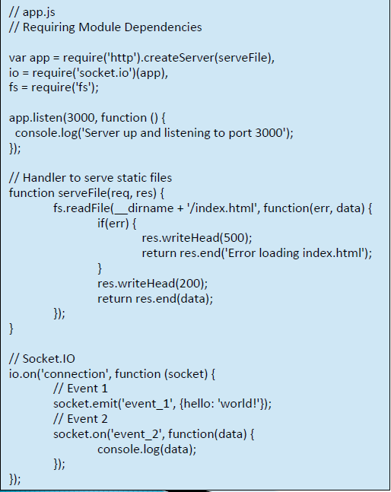**

**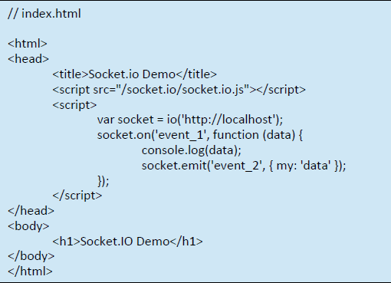**

#### ****FIG 3****

#### ****Express.js****

Express.js, or simply Express, is a web application framework for Node.js. Express [provides a robust set of features for web and mobile applications](https://expressjs.com/). Express provides a thin layer of fundamental web application features, without obscuring Node.js features.

There are many frameworks that can be added as modules to our Node application. These will be explained further on as needed.

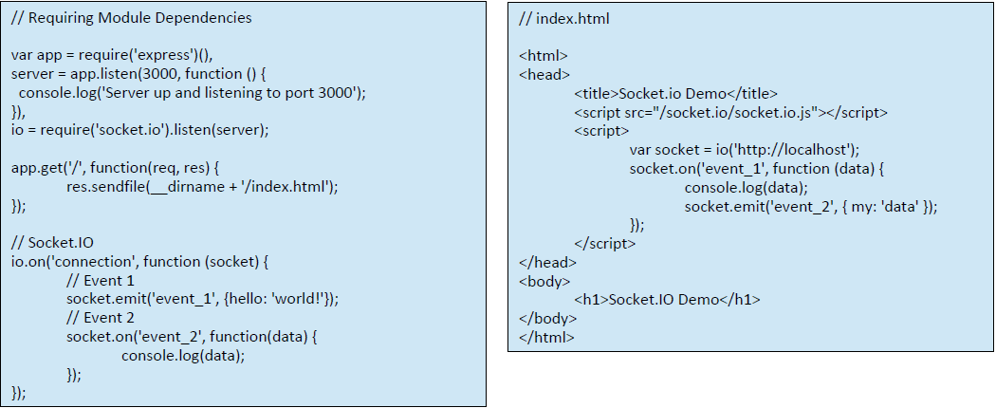

**FIG 4**

**2.11 Firing Event**

**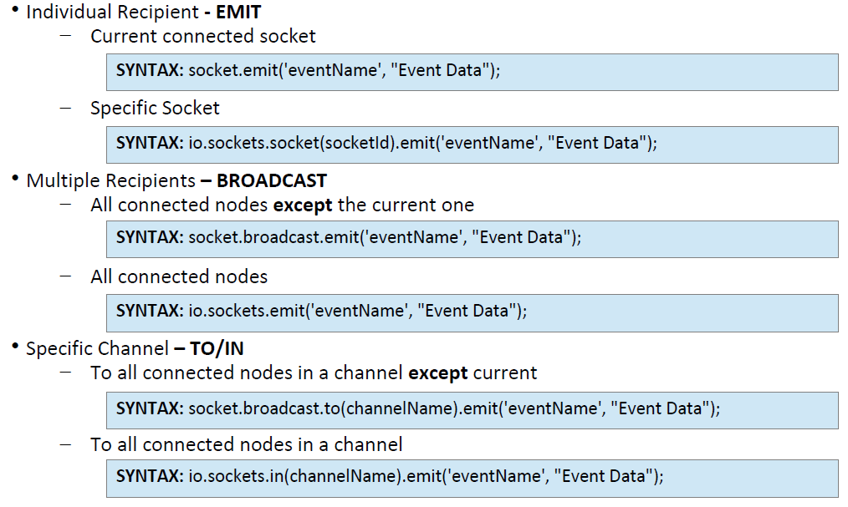**

**2.12 Listening to Events**

Listening to events is easier as compared to firing events

**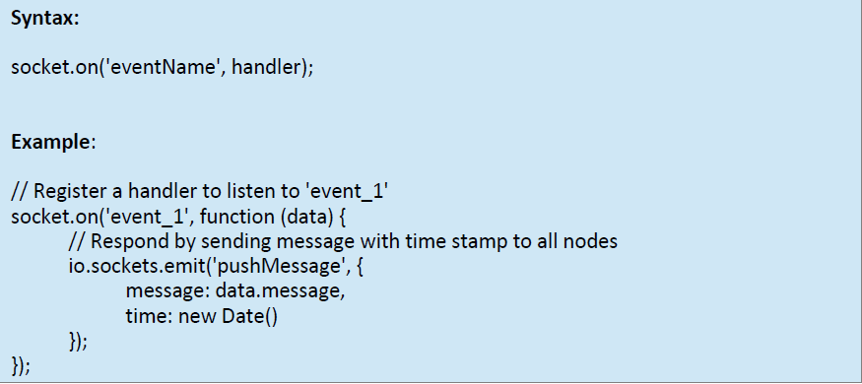**

**FIG 5**

**2.13 TECHNOLOGY ENVIRONMENT**

**2.14 Introduction to Visual Studio**

Visual Studio is an **Integrated Development Environment(IDE)** developed by Microsoft to develop GUI(Graphical User Interface), console, Web applications, web apps, mobile apps, cloud, and web services, etc. With the help of this IDE, you can create managed code as well as native code. It uses the various platforms of Microsoft software development software like Windows store, Microsoft Silverlight, and Windows API, etc. It is not a language-specific IDE as you can use this to write code in C#, C++, VB(Visual Basic), Python, JavaScript, and many more languages. It provides support for 36 different programming languages. It is available for Windows as well as for macOS.

**Evolution of Visual Studio:** The first version of VS(Visual Studio) was released in 1997, named as Visual Studio 97 having version number 5.0. The latest version of Visual Studio is 15.0 which was released on March 7, 2017. It is also termed as Visual Studio 2017. The supported *.Net Framework Versions* in latest Visual Studio is 3.5 to 4.7. Java was supported in old versions of Visual Studio but in the latest version doesn’t provide any support for Java language.

**Visual Studio Editions**

There are 3 editions of Microsoft Visual Studio as follows:

* + 1. **Community:** It is a **free** version which is announced in 2014. *All other editions are paid*. This contains the features similar to Professional edition. Using this edition, any individual developer can develop their own free or paid apps like *.Net applications*, Web applications and many more. In an enterprise organization, this edition has some limitations. For example, if your organization have more than 250 PCs and having annual revenue greater than $1 Million(US Dollars) then you are not permitted to use this edition. In a non-enterprise organization, up to five users can use this edition. Its main purpose is to provide the Ecosystem(Access to thousands of extensions) and Languages(You can code in C#, VB, F#, C++, HTML, JavaScript, Python, etc.) support.
    2. **Professional:** It is the commercial edition of Visual Studio. It comes in Visual Studio 2010 and later versions. It provides the support for XML and XSLT editing and includes the tool like Server Explorer and integration with Microsoft SQL Server. Microsoft provides a free trial of this edition and after the trial period, the user has to pay to continue using it. Its main purpose is to provide Flexibility(Professional developer tools for building any application type), Productivity(Powerful features such as CodeLens improve your team’s productivity), Collaboration(Agile project planning tools, charts, etc.) and Subscriber benefits like Microsoft software, plus Azure, Pluralsight, etc.
    3. **Enterprise:** It is an integrated, end to end solution for teams of any size with the demanding quality and scale needs. Microsoft provides a 90-days free trial of this edition and after the trial period, the user has to pay to continue using it. The main benefit of this edition is that it is highly scalable and deliver high-quality software.

**Getting Started with Visual Studio 2017**

* First, you must download and install the Visual Studio. For that, you can refer to **Downloading and Installing Visual Studio 2017**. Do not forget to select the .NET core workload during the installation of VS 2017. If you forget then you must **modify** the installation.
* You can see several tool windows when you will open the Visual Studio and start writing your first program as follows:

[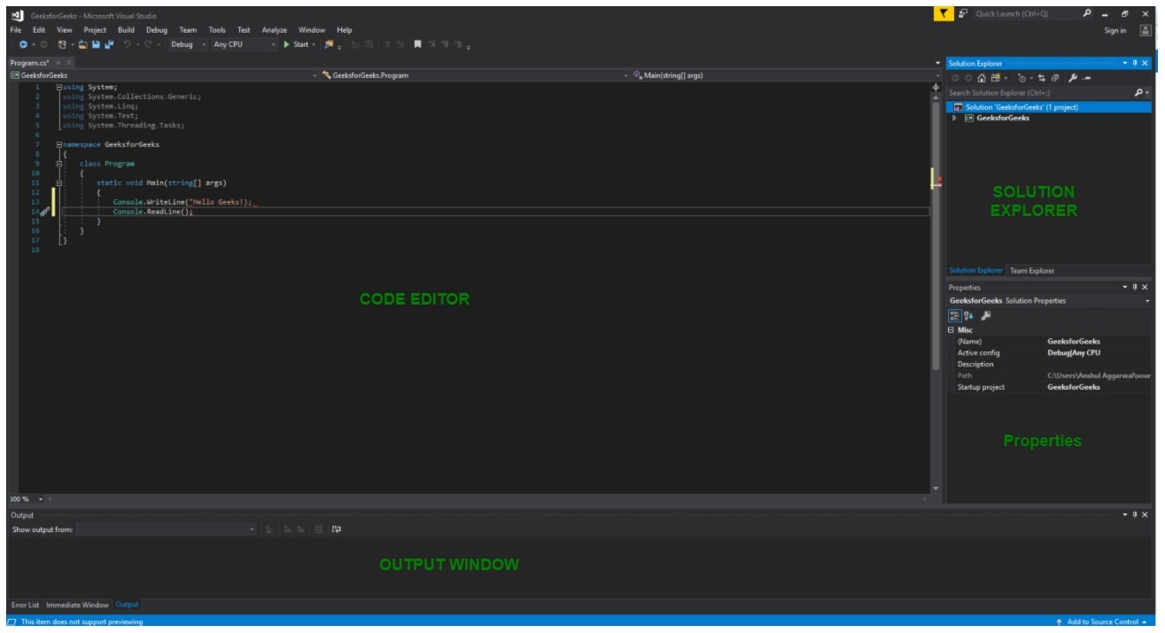](https://media.geeksforgeeks.org/wp-content/uploads/VS2017.jpg)

**FIG 6**

* 1. **Code Editor:** Where the user will write code.
  2. **Output Window:** Here the Visual Studio shows the outputs, compiler warnings, error messages and debugging information.
  3. **Solution Explorer:** It shows the files on which the user is currently working.
  4. **Properties:** It will give additional information and context about the selected parts of the current project.
* A user can also add windows as per requirement by choosing them from **View**menu. In Visual Studio the tool windows are customizable as a user can add more windows, remove the existing open one or can move windows around to best suit.
* **Various Menus in Visual Studio:**A user can find a lot of menus on the top screen of Visual Studio as shown below  
  [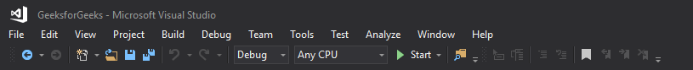](https://media.geeksforgeeks.org/wp-content/uploads/VS2017-2.png)

**FIG 7**

* 1. Create, Open and save projects commands are contained by **File**menu.
  2. Searching, Modifying, Refactoring code commands are contained by the **Edit**menu.
  3. **View**Menu is used to open the additional tool windows in Visual Studio.
  4. **Project**menu is used to add some files and dependencies in the project.
  5. To change the settings, add functionality to Visual Studio via extensions, and access various Visual Studio tools can be used by using **Tools**menu.
* The below menu is known as the **toolbar**which provide the quick access to the most frequently used commands. You can add and remove the commands by going to**View → Customize**

[](https://media.geeksforgeeks.org/wp-content/uploads/VS2017-3.png)

**FIG 8**

**Note:**

* Support for different programming languages in Visual Studio is added by using a special **VSPackage**which is known as *Language Service*.
* When you will install the Visual Studio then the functionality which is coded as VSPackage will be available as Service.
* Visual Studio IDE provides the three different types of services known as **SVsSolution**, **SVsUIShell**, and **SVsShell**.
* SVsSolution service is used to provide the functionality to enumerate solutions and projects in Visual Studio.
* SVsUIShell service is used to provide User Interface functionality like toolbars, tabs etc.
* SvsShell service is used to deal with the registration of VSPackages.

**2.15 Nodejs**

**Introduction to Nodejs -**

As an asynchronous event-driven JavaScript runtime, Node.js is designed to build scalable network applications. In the "hello world" example, many connections can be handled concurrently. Upon each connection, the call-back is fired, but if there is no work to be done, Node.js will sleep.

This is in contrast to today's more common concurrency model, in which OS threads are employed. Thread-based networking is relatively inefficient and very difficult to use. Furthermore, users of Node.js are free from worries of dead-locking the process, since there are no locks. Almost no function in Node.js directly performs I/O, so the process never blocks. Because nothing blocks, scalable systems are very reasonable to develop in Node.js.

Node.js is similar in design to, and influenced by, systems like Ruby's [Event Machine](https://github.com/eventmachine/eventmachine) and Python's [Twisted](https://twistedmatrix.com/trac/). Node.js takes the event model a bit further. It presents an [event loop](https://nodejs.org/en/docs/guides/event-loop-timers-and-nexttick/) as a runtime construct instead of as a library. In other systems, there is always a blocking call to start the event-loop. Typically, behaviour is defined through call-backs at the beginning of a script, and at the end a server is started through a blocking call like EventMachine::run(). In Node.js, there is no such start-the-event-loop call. Node.js simply enters the event loop after executing the input script. Node.js exits the event loop when there are no more call-backs to perform. This behaviour is like browser JavaScript — the event loop is hidden from the user.

HTTP is a first-class citizen in Node.js, designed with streaming and low latency in mind. This makes Node.js well suited for the foundation of a web library or framework.

Node.js being designed without threads doesn't mean you can't take advantage of multiple cores in your environment. Child processes can be spawned by using our [child\_process.fork()](https://nodejs.org/api/child_process.html" \l "child_process_child_process_fork_modulepath_args_options) API, and are designed to be easy to communicate with. Built upon that same interface is the [cluster](https://nodejs.org/api/cluster.html) module, which allows you to share sockets between processes to enable load balancing over your cores.

The [API reference documentation](https://nodejs.org/api/) provides detailed information about a function or object in Node.js. This documentation indicates what arguments a method accepts, the return value of that method, and what errors may be related to that method. It also indicates which methods are available for different versions of Node.js.

**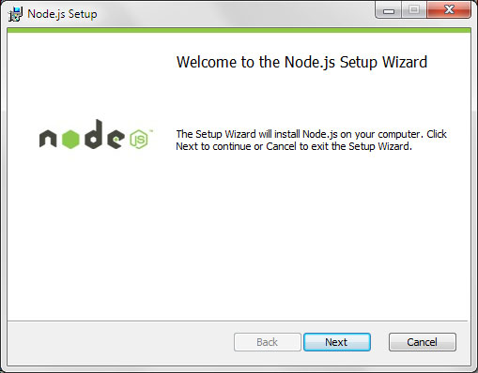**

**FIG 9**

**2.16 GITBASH**

Git is a fast, scalable, distributed revision control system with an unusually rich command set that provides both high-level operations and full access to internals.

See [gittutorial[7]](https://git-scm.com/docs/gittutorial) to get started, then see [giteveryday[7]](https://git-scm.com/docs/giteveryday) for a useful minimum set of commands. The [Git User’s Manual](https://git-scm.com/docs/user-manual) has a more in-depth introduction.

After you mastered the basic concepts, you can come back to this page to learn what commands Git offers. You can learn more about individual Git commands with "git help command". [gitcli[7]](https://git-scm.com/docs/gitcli) manual page gives you an overview of the command-line command syntax.

**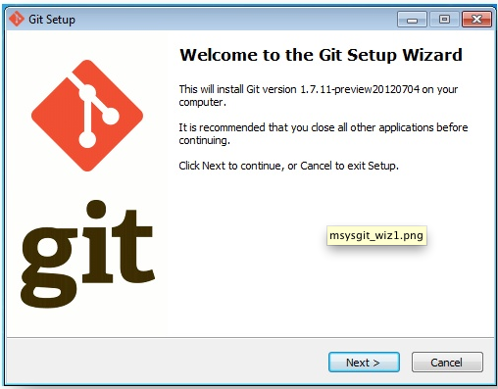**

**FIG 10**

**CHAPTER 3**

**3. CODING**

**3.1.TOTAL FILES IN THE PROJECT**

There are 2 folders and one server file and some utility files in this project .

* 1. **public**
  2. **utils**
  3. **server.js**

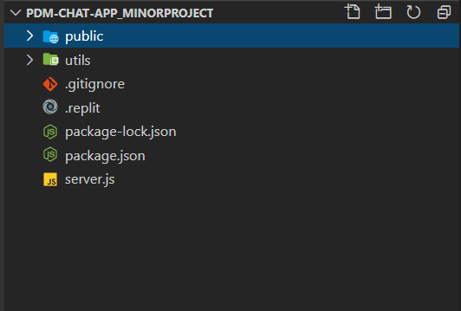

**FIG 11**

**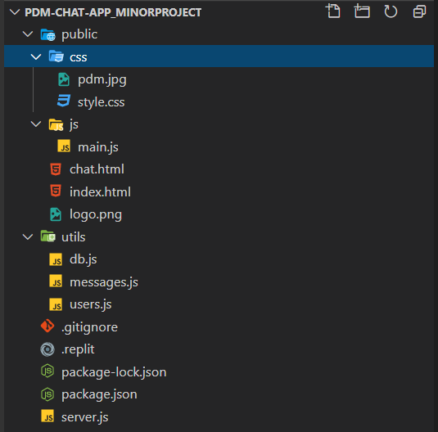**

**FIG 12**

1. **Public :-** There are 2 folder and 2 html file with a image file.
   1. **css :-** our css code .

@import url('https://fonts.googleapis.com/css?family=Roboto&display=swap');

:root {

--dark-color-a: #667aff;

--dark-color-b: #7386ff;

--light-color: #e6e9ff;

--success-color: #5cb85c;

--error-color: #d9534f;

}

\* {

box-sizing: border-box;

margin: 0;

padding: 0;

}

body {

font-family: 'Roboto', sans-serif;

font-size: 16px;

background-image: url("pdm.jpg") ;

background-size: cover;

margin: 20px;

}

ul {

list-style: none;

}

a {

text-decoration: none;

}

.btn {

cursor: pointer;

padding: 5px 15px;

background: var(--light-color);

color: var(--dark-color-a);

border: 0;

font-size: 17px;

}

/\* Chat Page \*/

.chat-container {

max-width: 1100px;

background: #fff;

margin: 30px auto;

overflow: hidden;

}

.chat-header {

background: var(--dark-color-a);

color: #fff;

border-top-left-radius: 5px;

border-top-right-radius: 5px;

padding: 15px;

display: flex;

align-items: center;

justify-content: space-between;

}

.chat-main {

display: grid;

grid-template-columns: 1fr 3fr;

}

.chat-sidebar {

background: var(--dark-color-b);

color: #fff;

padding: 20px 20px 60px;

overflow-y: scroll;

}

.chat-sidebar h2 {

font-size: 20px;

background: rgba(0, 0, 0, 0.1);

padding: 10px;

margin-bottom: 20px;

}

.chat-sidebar h3 {

margin-bottom: 15px;

}

.chat-sidebar ul li {

padding: 10px 0;

}

.chat-messages {

padding: 30px;

max-height: 500px;

overflow-y: scroll;

}

.chat-messages .message {

padding: 10px;

margin-bottom: 15px;

background-color: var(--light-color);

border-radius: 5px;

overflow-wrap: break-word;

}

.chat-messages .message .meta {

font-size: 15px;

font-weight: bold;

color: var(--dark-color-b);

opacity: 0.7;

margin-bottom: 7px;

}

.chat-messages .message .meta span {

color: #777;

}

.chat-form-container {

padding: 20px 30px;

background-color: var(--dark-color-a);

}

.chat-form-container form {

display: flex;

}

.chat-form-container input[type='text'] {

font-size: 16px;

padding: 5px;

height: 40px;

flex: 1;

}

/\* Join Page \*/

.join-container {

max-width: 500px;

margin: 80px auto;

color: #fff;

}

.join-header {

text-align: center;

padding: 20px;

background: var(--dark-color-a);

border-top-left-radius: 5px;

border-top-right-radius: 5px;

}

.join-main {

padding: 30px 40px;

background: var(--dark-color-b);

}

.join-main p {

margin-bottom: 20px;

}

.join-main .form-control {

margin-bottom: 20px;

}

.join-main label {

display: block;

margin-bottom: 5px;

}

.join-main input[type='text'] {

font-size: 16px;

padding: 5px;

height: 40px;

width: 100%;

}

.join-main select {

font-size: 16px;

padding: 5px;

height: 40px;

width: 100%;

}

.join-main .btn {

margin-top: 20px;

width: 100%;

}

@media (max-width: 700px) {

.chat-main {

display: block;

}

.chat-sidebar {

display: none;

}

}

* 1. **main.js :-**

const chatForm = document.getElementById('chat-form');

const chatMessages = document.querySelector('.chat-messages');

const roomName = document.getElementById('room-name');

const userList = document.getElementById('users');

// Get username and room from URL

const { username, room } = Qs.parse(location.search, {

ignoreQueryPrefix: true

});

const socket = io();

// Join chatroom

socket.emit('joinRoom', { username, room });

// Get room and users

socket.on('roomUsers', ({ room, users }) => {

outputRoomName(room);

outputUsers(users);

});

// Message from server

socket.on('message', message => {

console.log(message);

outputMessage(message);

// Scroll down

chatMessages.scrollTop = chatMessages.scrollHeight;

});

// Message submit

chatForm.addEventListener('submit', e => {

e.preventDefault();

// Get message text

let msg = e.target.elements.msg.value;

msg = msg.trim();

if (!msg){

return false;

}

// Emit message to server

socket.emit('chatMessage', msg);

// Clear input

e.target.elements.msg.value = '';

e.target.elements.msg.focus();

});

// Output message to DOM

function outputMessage(message) {

const div = document.createElement('div');

div.classList.add('message');

const p = document.createElement('p');

p.classList.add('meta');

p.innerText = message.username;

p.innerHTML += `<span>${message.time}</span>`;

div.appendChild(p);

const para = document.createElement('p');

para.classList.add('text');

para.innerText = message.text;

div.appendChild(para);

document.querySelector('.chat-messages').appendChild(div);

}

// Add room name to DOM

function outputRoomName(room) {

roomName.innerText = room;

}

// Add users to DOM

function outputUsers(users) {

userList.innerHTML = '';

users.forEach(user=>{

const li = document.createElement('li');

li.innerText = user.username;

userList.appendChild(li);

});

}

* 1. **Chat.html :-**

<!DOCTYPE html>

<html lang="en">

<head>

<meta charset="UTF-8" />

<meta name="viewport" content="width=device-width, initial-scale=1.0" />

<link

rel="stylesheet"

href="https://cdnjs.cloudflare.com/ajax/libs/font-awesome/5.12.1/css/all.min.css"

integrity="sha256-mmgLkCYLUQbXn0B1SRqzHar6dCnv9oZFPEC1g1cwlkk="

crossorigin="anonymous"

/>

<link rel="stylesheet" href="css/style.css" />

<title>PDMChat App</title>

</head>

<body>

<div class="chat-container">

<header class="chat-header">

<h1><img src="./logo.png" alt=""></h1>

<a href="index.html" class="btn">Leave Room</a>

</header>

<main class="chat-main">

<div class="chat-sidebar">

<h3><i class="fas fa-comments"></i> Room Name:</h3>

<h2 id="room-name"></h2>

<h3><i class="fas fa-users"></i> Users</h3>

<ul id="users"></ul>

</div>

<div class="chat-messages"></div>

</main>

<div class="chat-form-container">

<form id="chat-form">

<input

id="msg"

type="text"

placeholder="Enter Message"

required

autocomplete="off"

/>

<button class="btn"><i class="fas fa-paper-plane"></i> Send</button>

</form>

</div>

</div>

<script

src="https://cdnjs.cloudflare.com/ajax/libs/qs/6.9.2/qs.min.js"

integrity="sha256-TDxXjkAUay70ae/QJBEpGKkpVslXaHHayklIVglFRT4="

crossorigin="anonymous"

></script>

<script src="/socket.io/socket.io.js"></script>

<script src="js/main.js"></script>

</body>

</html>

* 1. **Index.html :-**

<!DOCTYPE html>

<html lang="en">

<head>

<meta charset="UTF-8" />

<meta name="viewport" content="width=device-width, initial-scale=1.0" />

<meta http-equiv="X-UA-Compatible" content="ie=edge" />

<link

rel="stylesheet"

href="https://cdnjs.cloudflare.com/ajax/libs/font-awesome/5.12.1/css/all.min.css"

integrity="sha256-mmgLkCYLUQbXn0B1SRqzHar6dCnv9oZFPEC1g1cwlkk="

crossorigin="anonymous"

/>

<link rel="stylesheet" href="css/style.css" />

<title>PDMChat App</title>

</head>

<body>

<div class="join-container">

<header class="join-header">

<h1>

<!-- <i class="fas fa-smile"> -->

<img src="./logo.png" alt="">

<!-- </i> PDMChat</h1> -->

</header>

<main class="join-main">

<form action="chat.html">

<div class="form-control">

<label for="username">Username</label>

<input

type="text"

name="username"

id="username"

placeholder="Enter username..."

required

/>

</div>

<div class="form-control">

<label for="room">Room</label>

<select name="room" id="room">

<option value=" ENGINEERING ">ENGINEERING</option>

<option value="PHARMACY">PHARMACY</option>

<option value="LIFESCIENCE">LIFESCIENCE</option>

<option value="BCA">BCA</option>

<option value="DENTAL">DENTAL</option>

<option value="LLB">LLB</option>

</select>

</div>

<button type="submit" class="btn">Join Chat</button>

</form>

</main>

</div>

</body>

</html>

1. **Utils :-** There are 3 file in this folder
   1. **db.js :-**

var MongoClient = require('mongodb').MongoClient;

var url = "mongodb://localhost:27017/pdmchatapp";

MongoClient.connect(url, function(err, db) {

if (err) {

throw err;

}

console.log("connect to pdmchatapp");

client.on('connection', function(){

let chat = db.collection('chat');

sendStatus = (s)=>{

socket.emit('status',s);

}

chat.find().limit(100).sort({\_id:1}).toArray(function(err,res){

if(err){

throw err;

}

socket.emit('output',res);

});

socket.on('input', function(){

let name = data.name;

let message = data.message;

if(name == '' || message == ''){

sendStatus('plss enter the message');

}

else{

chat.insert({name:name, message:message} , function(){

client.emit('output',[data]);

sendStatus({

message: 'Message sent',

clear : true

})

})

}

})

});

});

2.2 **messages.js :-**

const moment = require('moment');

function formatMessage(username, text) {

return {

username,

text,

time: moment().format('h:mm a')

};

}

module.exports = formatMessage;

* 1. **users.js :-**

const users = [];

// Join user to chat

function userJoin(id, username, room) {

const user = { id, username, room };

users.push(user);

return user;

}

// Get current user

function getCurrentUser(id) {

return users.find(user => user.id === id);

}

// User leaves chat

function userLeave(id) {

const index = users.findIndex(user => user.id === id);

if (index !== -1) {

return users.splice(index, 1)[0];

}

}

// Get room users

function getRoomUsers(room) {

return users.filter(user => user.room === room);

}

module.exports = {

userJoin,

getCurrentUser,

userLeave,

getRoomUsers

};

1. **server.js :-**

const path = require('path');

const http = require('http');

const express = require('express');

const socketio = require('socket.io');

const formatMessage = require('./utils/messages');

const {

userJoin,

getCurrentUser,

userLeave,

getRoomUsers

} = require('./utils/users');

const app = express();

const server = http.createServer(app);

const io = socketio(server);

// Set static folder

app.use(express.static(path.join(\_\_dirname, 'public')));

const botName = 'PDM UNIVERSITY';

// Run when client connects

io.on('connection', socket => {

socket.on('joinRoom', ({ username, room }) => {

const user = userJoin(socket.id, username, room);

socket.join(user.room);

// Welcome current user

socket.emit('message', formatMessage(botName, 'Welcome to PDM UNIVERSITY!'));

// Broadcast when a user connects

socket.broadcast

.to(user.room)

.emit(

'message',

formatMessage(botName, `${user.username} has joined the chat`)

);

// Send users and room info

io.to(user.room).emit('roomUsers', {

room: user.room,

users: getRoomUsers(user.room)

});

});

// Listen for chatMessage

socket.on('chatMessage', msg => {

const user = getCurrentUser(socket.id);

io.to(user.room).emit('message', formatMessage(user.username, msg));

});

// Runs when client disconnects

socket.on('disconnect', () => {

const user = userLeave(socket.id);

if (user) {

io.to(user.room).emit(

'message',

formatMessage(botName, `${user.username} has left the chat`)

);

// Send users and room info

io.to(user.room).emit('roomUsers', {

room: user.room,

users: getRoomUsers(user.room)

});

}

});

});

const PORT = process.env.PORT || 3000;

server.listen(PORT, () => console.log(`Server running on port ${PORT}`));

GITHUB link for the project :- <https://github.com/blackhatabhi/Pdm-chat-app_minorProject>

Project online at :- <https://pdmchatapp.herokuapp.com/>

**CHAPTER 4**

**4. TESTING & RESULT**

**4.1. BASIC VIEW OF THE PROJECT**

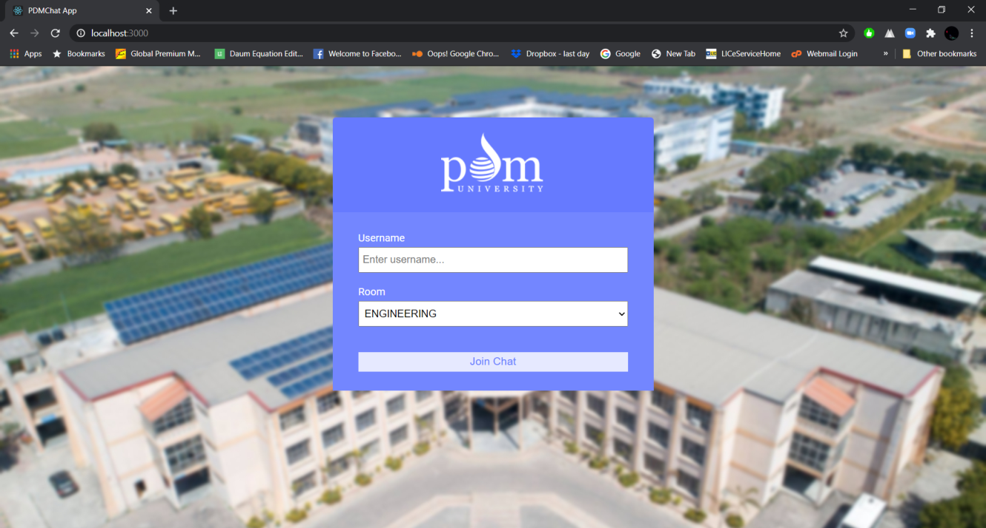

**FIG 13**

* 1. **. A NEW USER JOIN A ROOM: -**

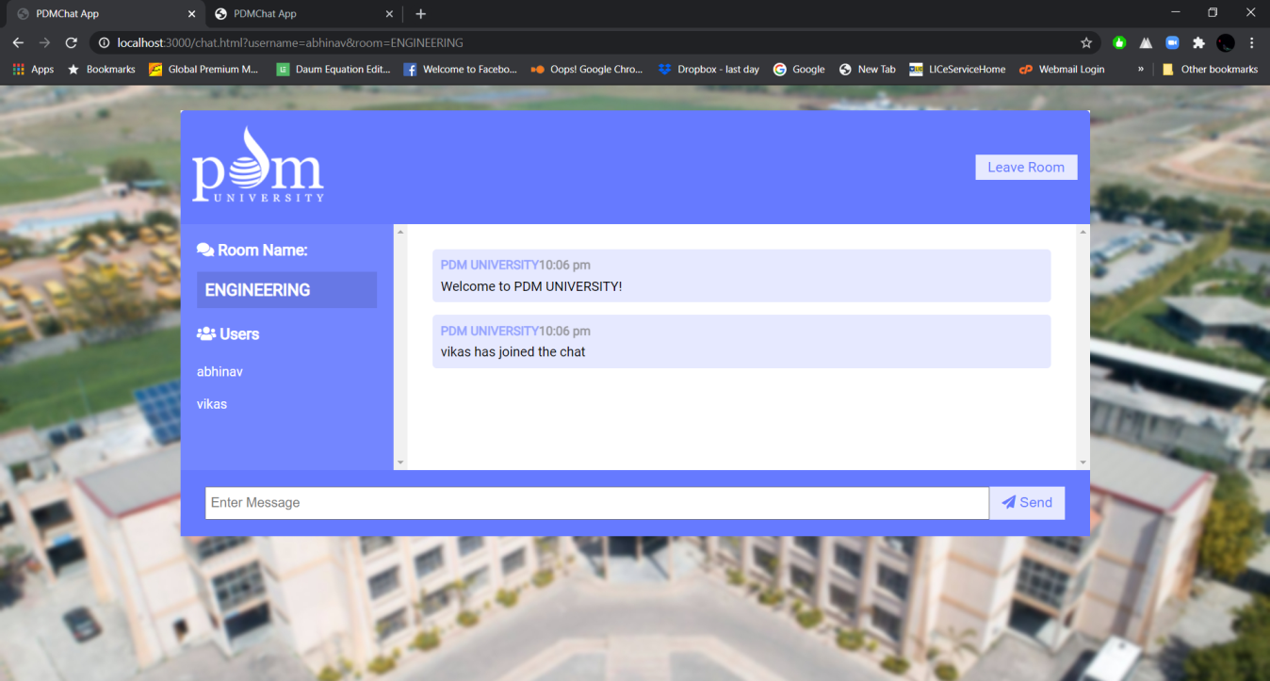

**FIG 14**

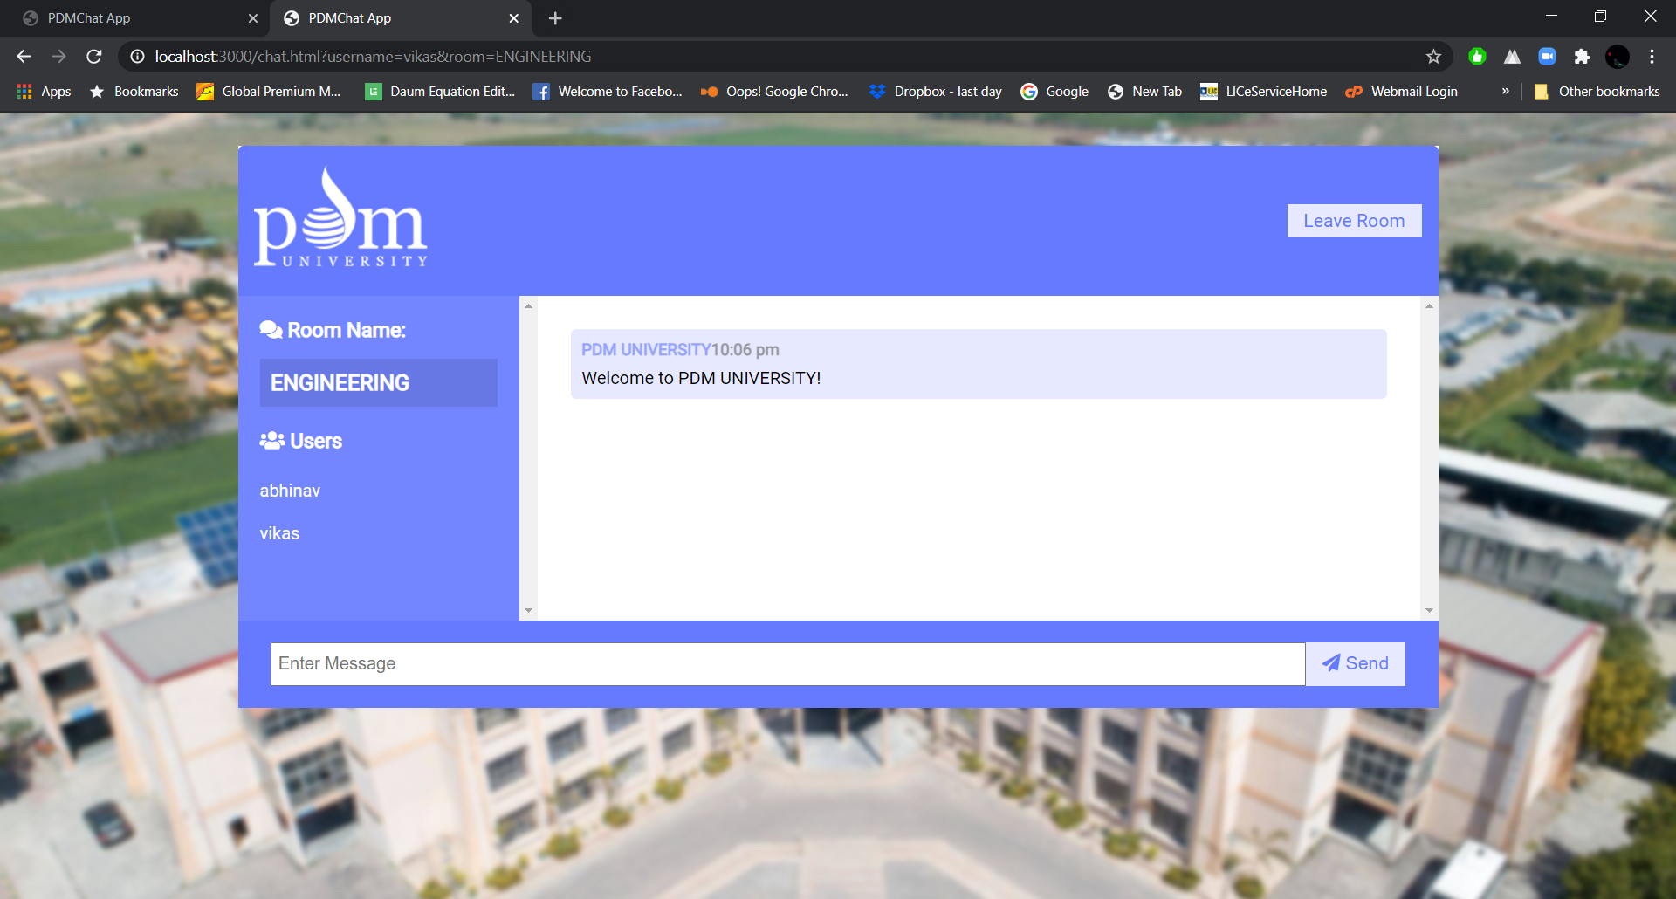

**FIG 15**

**4.3 CHAT USING WEB SOCKETS: -**

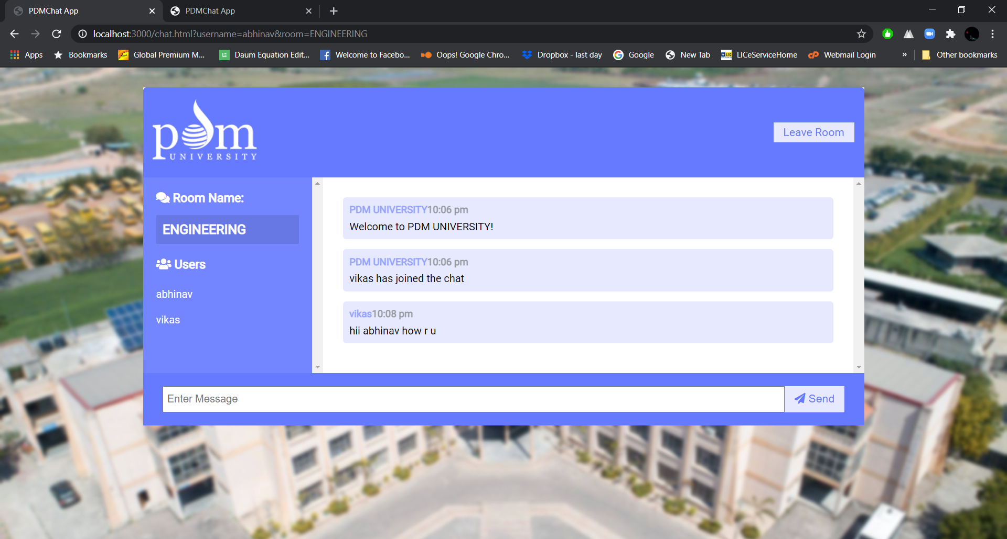

**FIG 16**

* 1. **CHAT USING WEB SOCKETS IN A DIFFERENT: -**

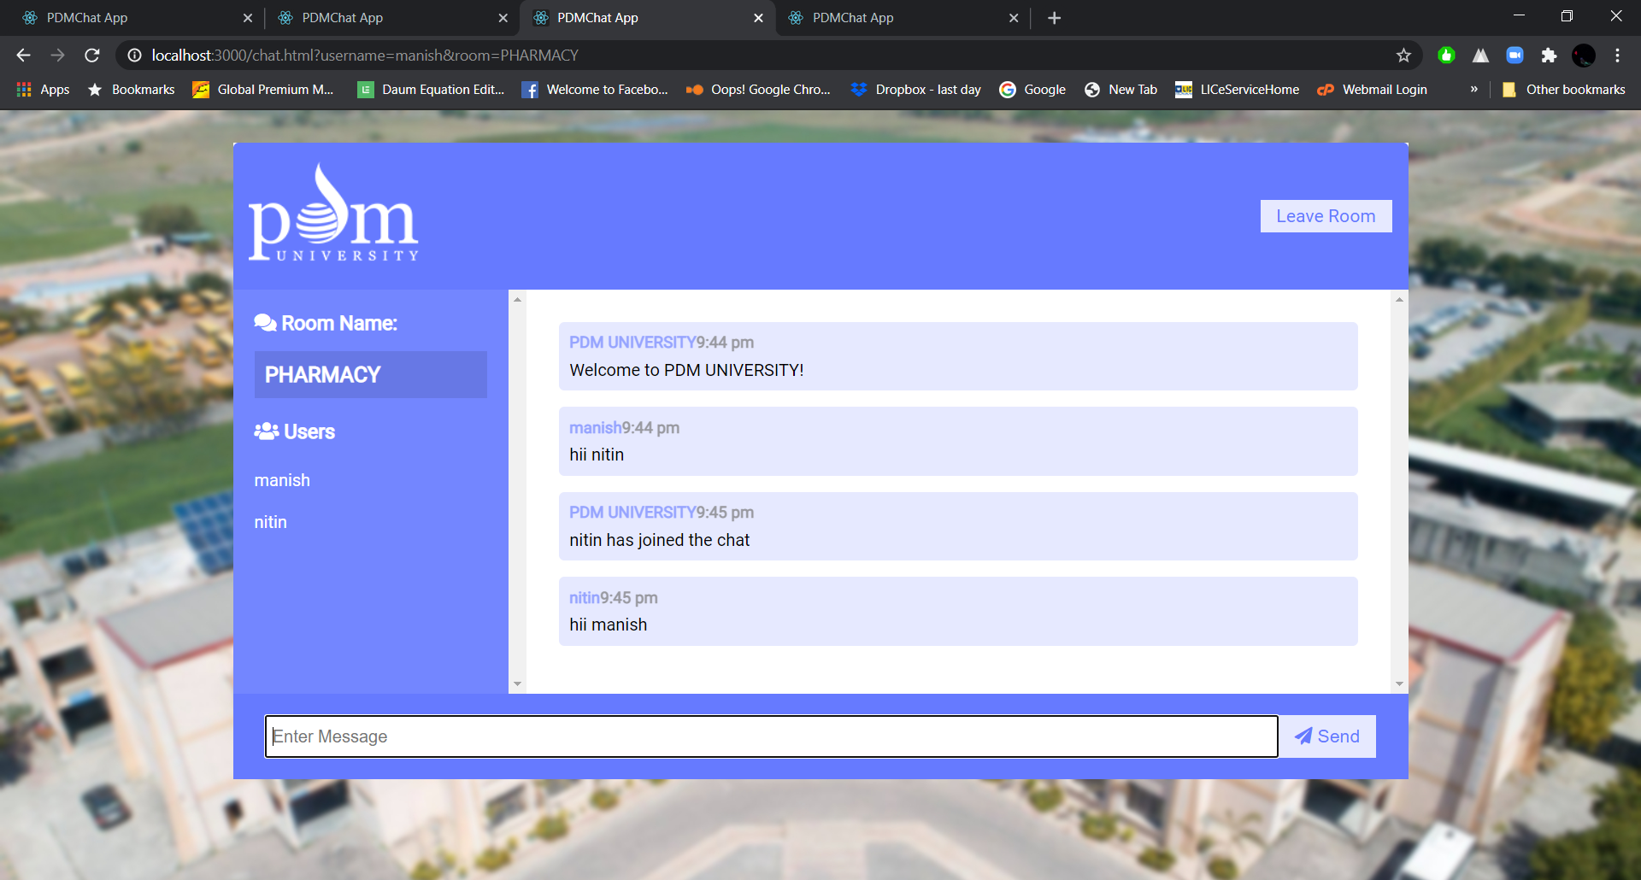

**FIG 17**

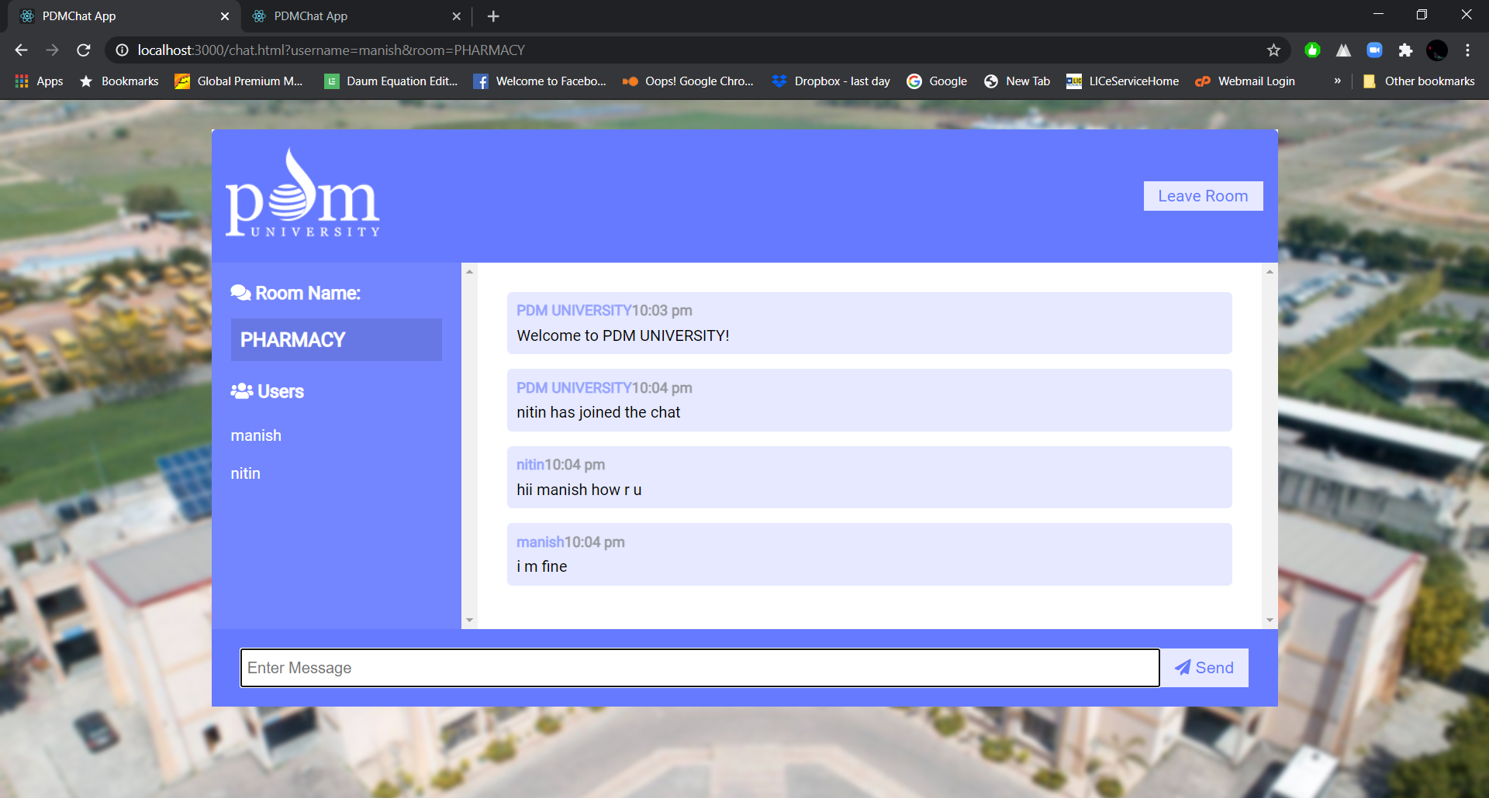

**FIG 18**

4.4 **WHEN SOMEONE LEAVES THE CHAT ROOM**

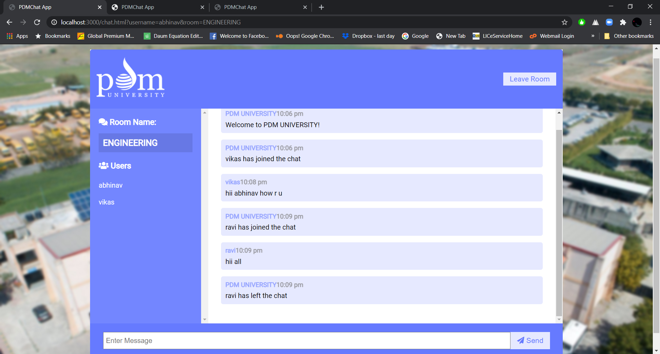

**FIG 18**

**RESULT :- we have successfully compiled our projects with some minor bug fixes such as background mirroring , chat message forwarding to different rooms and some textual bugs.**